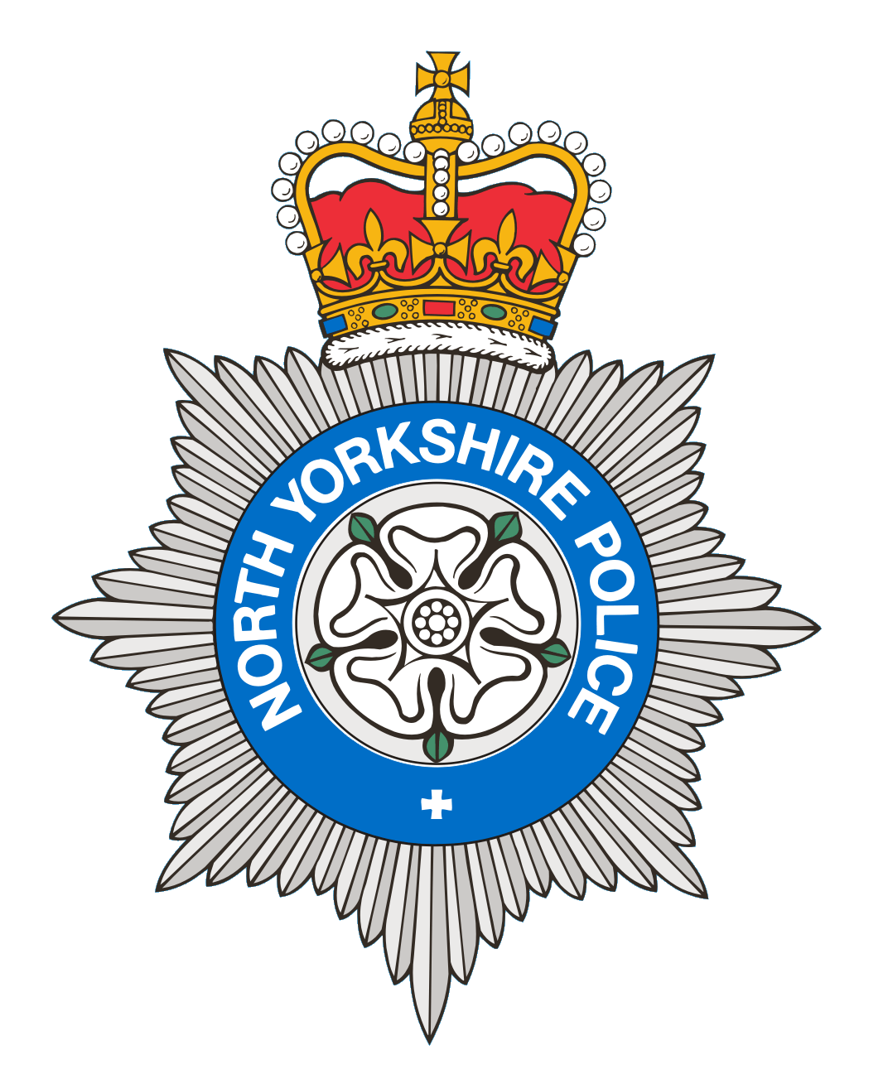
PCSO 5725
Produced: 19th October 2026
Date of meeting- 2026

BROUGH WITH ST GILES
PARISH COUNCIL MEETING 2026
POLICE REPORT

22/08/2026 – 21/09/2026

Please note that under the police crime reporting system, all reports of criminal activity are recorded as crimes. However, if at a later date it is ascertained that no crime has been committed, this will not show on parish council report due to time delay.

Crimes = 3
1 Report of Crime Violence, 3 females were arrested for violence on a male. 1 Report of Crime/Theft, which was theft of fuel. 1 report of Crime/Fraud, family related fraud which has been resolved.
Reported crime for the same period last year = 3

Anti-Social Behaviour = 0
Reports of ASB for the same period last year = 4

OTHER REPORTS includes Highway Disruption and RTC’s

1 Highway Disruption - 1 report of a vehicle obstructing a pavement, which is an ongoing issue.
Other reports for the same period last year= 1

Personal/Safety/Warning Incidents = 3

1 Report of concern – No concerns were found.

2 Reports of Suspicious behaviour – 2 reports of suspicious males, all were in order and of good intention.

0 Reports of Domestic Incidents.
0 report of an abandoned call
0 report of a missing person
Other reports for the same period last year = 11

Community Messaging
North Yorkshire Community Messaging allows members of the public to register to receive alerts, crime notifications and community news from organisations. It is a way of maintaining contact with Neighbourhood Watch and Rural Watch groups. Neighbourhood & Rural Watch have their own database within community messaging for their members.

​You can sign up to receive alerts as a member of the public here:
https://www.northyorkshirecommunitymessaging.co.uk/

If you wish to speak to your local Neighbourhood PCSO you can send an e-mail to PCSO 5725 Jamie-Leigh Coburn
jamie-leigh.Coburn@northyorkshire.police.uk phone 101, choose option 2, and follow the prompts.

